**TWISTED PAIR :**

Twisted pair cabling is a type of wiring in which two conductors of a single [circuit](https://en.wikipedia.org/wiki/Electronic_circuit" \o "Electronic circuit) are twisted together for the purposes of improving [electromagnetic compatibility](https://en.wikipedia.org/wiki/Electromagnetic_compatibility" \o "Electromagnetic compatibility). Compared to a [single conductor](https://en.wikipedia.org/wiki/Single-ended_signaling" \o "Single-ended signaling) or an untwisted [balanced pair](https://en.wikipedia.org/wiki/Balanced_pair" \o "Balanced pair), a twisted pair reduces [electromagnetic radiation](https://en.wikipedia.org/wiki/Electromagnetic_radiation" \o "Electromagnetic radiation) from the pair and [crosstalk](https://en.wikipedia.org/wiki/Crosstalk" \o "Crosstalk) between neighboring pairs and improves rejection of external [electromagnetic interference](https://en.wikipedia.org/wiki/Electromagnetic_interference" \o "Electromagnetic interference).

A twisted pair can be used as a [balanced line](https://en.wikipedia.org/wiki/Balanced_line" \o "Balanced line), which as part of a [balanced circuit](https://en.wikipedia.org/wiki/Balanced_circuit" \o "Balanced circuit) can greatly reduce the effect of noise currents induced on the line by coupling of electric or magnetic fields. The idea is that the currents induced in each of the two wires are very nearly equal. The twisting ensures that the two wires are on average the same distance from the [interfering source](https://en.wikipedia.org/wiki/Electromagnetic_interference" \o "Electromagnetic interference) and are affected equally. The noise thus produces a [common-mode signal](https://en.wikipedia.org/wiki/Common-mode_signal" \o "Common-mode signal) which can be cancelled at the receiver by detecting the difference signal only, the latter being the wanted signal.

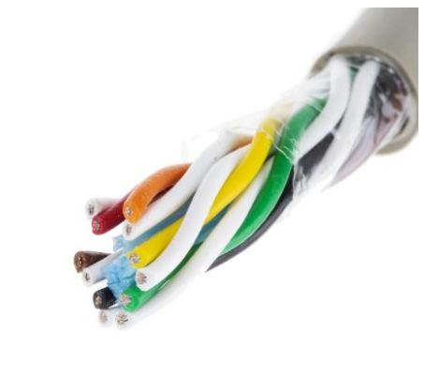

**COAXIAL CABLE :**

[Conductor](https://en.wikipedia.org/wiki/Electrical_conductor" \o "Electrical conductor) surrounded by a concentric conducting [shield](https://en.wikipedia.org/wiki/Electromagnetic_shielding" \o "Electromagnetic shielding), with the two separated by a [dielectric](https://en.wikipedia.org/wiki/Dielectric" \o "Dielectric) ([insulating](https://en.wikipedia.org/wiki/Insulator_(electricity)" \o "Insulator (electricity)) material); many coaxial cables also have a protective outer sheath or jacket. The term "[coaxial](https://en.wikipedia.org/wiki/Coaxial" \o "Coaxial)" refers to the inner conductor and the outer shield sharing a geometric axis.

Coaxial cable is a type of [transmission line](https://en.wikipedia.org/wiki/Transmission_line" \o "Transmission line), used to carry high-frequency [electrical signals](https://en.wikipedia.org/wiki/Electrical_signal" \o "Electrical signal) with low losses. It is used in such applications as telephone trunklines, [broCoaxial cable is a type of](https://en.wikipedia.org/wiki/Internet_access" \o "Internet access)[electrical cable](https://en.wikipedia.org/wiki/Electrical_cable" \o "Electrical cable)[consisting of an inner adband internet](https://en.wikipedia.org/wiki/Internet_access" \o "Internet access) networking cables, high-speed computer [data busses](https://en.wikipedia.org/wiki/Bus_(computer)" \o "Bus (computer)), [cable television](https://en.wikipedia.org/wiki/Cable_television" \o "Cable television) signals, and connecting [radio transmitters](https://en.wikipedia.org/wiki/Transmitter" \o "Transmitter) and [receivers](https://en.wikipedia.org/wiki/Radio_receiver" \o "Radio receiver) to their [antennas](https://en.wikipedia.org/wiki/Antenna_(radio)" \o "Antenna (radio)). It differs from other [shielded cables](https://en.wikipedia.org/wiki/Shielded_cable" \o "Shielded cable) because the dimensions of the cable and connectors are controlled to give a precise, constant conductor spacing, which is needed for it to function efficiently as a transmission line.

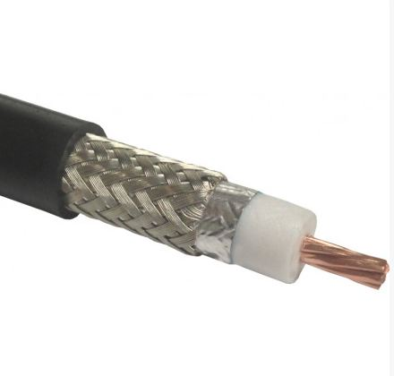

**OPTICAL FIBER :**

An optical fiber is a flexible, [transparent](https://en.wikipedia.org/wiki/Transparency_and_translucency" \o "Transparency and translucency) [fiber](https://en.wikipedia.org/wiki/Fiber" \o "Fiber) made by [drawing](https://en.wikipedia.org/wiki/Drawing_(manufacturing)" \o "Drawing (manufacturing)) [glass](https://en.wikipedia.org/wiki/Glass" \o "Glass) ([silica](https://en.wikipedia.org/wiki/Silica" \o "Silica)) or plastic to a diameter slightly thicker than that of a [human hair](https://en.wikipedia.org/wiki/Hair's_breadth" \o "Hair's breadth). Optical fibers are used most often as a means to transmit light[[a]](https://en.wikipedia.org/wiki/Optical_fiber" \l "cite_note-2) between the two ends of the fiber and find wide usage in [fiber-optic communications](https://en.wikipedia.org/wiki/Fiber-optic_communication" \o "Fiber-optic communication), where they permit transmission over longer distances and at higher [bandwidths](https://en.wikipedia.org/wiki/Bandwidth_(computing)" \o "Bandwidth (computing)) (data transfer rates) than electrical cables. Fibers are used instead of [metal](https://en.wikipedia.org/wiki/Metal" \o "Metal) wires because signals travel along them with less [loss](https://en.wikipedia.org/wiki/Attenuation" \o "Attenuation); in addition, fibers are immune to [electromagnetic interference](https://en.wikipedia.org/wiki/Electromagnetic_interference" \o "Electromagnetic interference), a problem from which metal wires suffer. Fibers are also used for [illumination](https://en.wikipedia.org/wiki/Illumination_(lighting)" \o "Illumination (lighting)) and imaging, and are often wrapped in bundles so they may be used to carry light into, or images out of confined spaces, as in the case of a [fiberscope](https://en.wikipedia.org/wiki/Fiberscope" \o "Fiberscope).Specially designed fibers are also used for a variety of other applications, some of them being [fiber optic sensors](https://en.wikipedia.org/wiki/Fiber_optic_sensor" \o "Fiber optic sensor) and [fiber lasers](https://en.wikipedia.org/wiki/Fiber_laser" \o "Fiber laser).

Optical fibers typically include a [core](https://en.wikipedia.org/wiki/Core_(optical_fiber)" \o "Core (optical fiber)) surrounded by a transparent [cladding](https://en.wikipedia.org/wiki/Cladding_(fiber_optics)" \o "Cladding (fiber optics)) material with a lower [index of refraction](https://en.wikipedia.org/wiki/Index_of_refraction" \o "Index of refraction). Light is kept in the core by the phenomenon of [total internal reflection](https://en.wikipedia.org/wiki/Total_internal_reflection" \o "Total internal reflection) which causes the fiber to act as a [waveguide](https://en.wikipedia.org/wiki/Waveguide_(optics)" \o "Waveguide (optics)). Fibers that support many propagation paths or [transverse modes](https://en.wikipedia.org/wiki/Transverse_mode" \o "Transverse mode) are called [multi-mode fibers](https://en.wikipedia.org/wiki/Multi-mode_fiber" \o "Multi-mode fiber), while those that support a single mode are called [single-mode fibers](https://en.wikipedia.org/wiki/Single-mode_fiber" \o "Single-mode fiber) (SMF). Multi-mode fibers generally have a wider core diameter and are used for short-distance communication links and for applications where high power must be transmitted. Single-mode fibers are used for most communication links longer than 1,000 metert.s (3,300 ft)

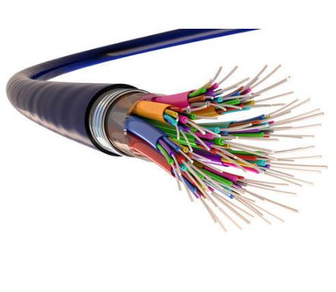

# \_\_\_\_\_\_\_\_\_\_\_\_\_\_\_\_\_\_\_\_\_\_\_\_\_\_\_\_\_\_\_

## 16 Difference Between Twisted Pair, Coaxial Cable And Fiber Optic Cable In Tabular Form

|  |  |  |  |
| --- | --- | --- | --- |
| ****BASIS OF COMPARISON**** | ****TWISTED PAIR CABLE**** | ****COAXIAL CABLE**** | ****FIBER OPTIC CABLE**** |
| ****Alternative Name**** | \_\_\_\_ | Coaxial cable can also be referred to as ****coax cable.**** | Fiber optic cable also referred to as ****optical fiber cable.**** |
| ****Description**** | Twisted Pair cable is a kind of wiring in which two conductors of a single circuit are twisted together. A pair of wires forms a circuit that can transmit data. | Coaxial cable is designed to transmit high-frequency signals. It is comprised of a round copper conductor and three layers of insulation and shielding which prevents crosstalk from motors, lighting and other sources of EMI. | Fiber optic cable also referred to as optical fiber cable, is a type of Ethernet cable which consist of one or more optic fibers that are used to transmit data. |
| ****Types**** | Unshielded Twisted Pair (UTP) Shielded Twisted Pair (STP) | RG59 RG6 | Single mode fiber (SMF)  Multimode fiber (MMF). |
| ****Transmission Of Signal**** | Transmission of signals takes place in the electrical form over metallic conducting wire. | Transmission of signal is in electrical form over the inner conductor of the cable. | Signal transmission takes place in light forms over a glass fiber. |
| ****External Magnetic Field**** | It can be affected due to external magnetic field. | It is less affected due to external magnetic field. | It is never affected due to external magnetic field. |
| ****Made Up Of**** | It is made up of a pair of insulated copper wire. | It is made up of four components moving from inside to the outside: a solid conductor wire, a layer of insulation, a grounding conductor and a layer of exterior insulation. | They are made up of very thin optical fibers bundled together into a single cable. The fibers can be made of glass or plastic. |
| ****Price**** | They are comparatively low in price when compared to both Coaxial and Fiber optical cables. | The cost of coaxial cables is higher than that of twisted pair cables. | Fiber optic cable is more expensive than copper cable due to its high performance and capacity cables. |
| ****Noise Rejection**** | It is usually not effective in rejecting this noise | They are relatively good at rejecting noise when compared to twisted pair cables. | It has highest noise immunity as the light rays are unaffected by the electrical noise. |
| ****Attenuation**** | Attenuation is very high. | Attenuation is low. | Attenuation is very much low. |
| ****Installation & Implementation**** | Installation and implementation of twisted pair cables is simple and easy. | Installation and implementation of coaxial cable is relatively difficult. | Installation and implementation of optical fiber is difficult. |
| ****Bandwidth**** | Low Bandwidth. | Moderately high bandwidth. | Very high bandwidth. |
| ****Security**** | The security of transmitted signal is not guaranteed. | The security of transmitted signal is not guaranteed. | It is hard to tap fiber-optic cables without also disrupting the system. Security of transmitted signal is guaranteed. |
| ****Application**** | They are generally used in telephone networks, data networks and cable shielding. | They are used in feedlines connecting radio transmitters and receivers with their antennas, computer network (Internet) connections, digital audio (S/PDIF) and distributing cable television signals. | They are installed to support long distance connections between countries and cities. They are also used in data centers where large volume of data needs to be transmitted. |
| ****Transmission Speed**** | They transmit television, telephone and data at a relatively low speed when compared to fiber optical cable. | They transmit television, telephone and data at a relatively low speed when compared to fiber optical cable. | They transmit television, telephone and data at a relatively faster speed when compared to twisted pair and coaxial cable. |
| ****Diameter**** | They are larger in diameter than fiber optical cables. | They are larger in diameter than fiber optical cables. | They are small in diameter. |
| ****Weight**** | They are heavier in weight when compared to fiber optical cables. | They are heavier in weight when compared to fiber optical cables. | They are lighter in weight when compared to twisted pair and coaxial cables. |
| ****Type Of Loss Occurring In The Cable**** | Resistive loss, Dielectric loss, Radiated loss and Loss over time. | Resistive loss, Dielectric loss and Radiated loss. | Dispersion, bending, absorption and attenuation. |